 | Contacts
 | Rocket name: |  | XOZ-XL
 | Owner: |  | Leo Deelman |  |  |  |  |  |  | Club: |  |  |  |  |  | Nero
 | Mobile telephone: |  |  |  |  |  |  |  |  | Date: |  |  |  |  |  | 17-8-2015
 | E-mail:
 | General
 | Type (Experimental/HP/Model): |  | Experimental |  |  |  |  |  | Number of stages: |  |  |  |  |  |  |  |  |  |  |  |  | 1
 |  |  | Total length: |  |  | Diameter: |  |  |  |  |  |  |  |  |  | Start weight:
 | Dimensions: |  | 262 | cm |  | 10 |  |  |  |  | cm |  |  |  |  | 16.6 |  |  |  |  | kg
 |  |  | Body: |  |  |  |  |  | Finns:
 | Colours: |  | Alu/ black/neon orange |  |  |  |  |  | Carbon plate black
 |  |  | Centre of Pressure: |  |  | Centre of Mass: |  |  |  |  |  |  |  |  |  | Static Margin:
 | Centre's (from nose-tip): |  | 195 | cm |  | 171 |  |  |  |  | cm |  |  |  |  | 2.45 |  |  |  |  | #
 |  |  | With same motor: |  |  | With other motor:
 | Rocket flown before: |  | yes | # |  |  |  |  |  |  | #
 | Motor Specification
 | Motor name: |  | 6G-90mm-LEO |  |  |  |  |  |  |  |  |  | Multiple nozzle:
 | :
 | Manufacturer: |  | Leo Deelman |  |  | Validation date: |  |  |  |  |  |  |  |  |  |  | / |  | /
 | Propellant composition: |  | Sorbitol/KNO3/ iron oxide
 |  |  | Casing id.: |  |  | Number of times used; |  |  |  |  |  |  |  |  |  | Date last use;
 | Casing: |  | 1 | # |  | 1 |  |  |  |  | # |  |  |  |  |  |  | NLD2014-2
 |  |  | Propellant mass: |  |  | Total impulse: |  |  |  |  |  |  |  |  |  | Burning time:
 | Characteristics: |  | 4.9 | kg |  | 5600 |  |  |  |  | Ns |  |  |  |  | 4.7 |  |  |  |  | s
 |  |  | Type: |  |  | Necessary current: |  |  |  |  |  |  |  |  |  | During:
 | Igniter: |  | Nero supplied/Fuse head |  |  |  |  |  |  |  |  | mA |  |  |  |  |  |  |  |  | s
 | Flight control
 | Flight control device: |  | Altus metrum mini/ timer backup (accel triggered)
 | Flight Characteristics
 |  |  | Tower exit velocity: |  |  | Maximum velocity: |  |  |  |  |  |  |  |  |  | Impact range:
 | Characteristics: |  | 26.6 | m/s |  | 295 |  |  |  |  | m/s |  |  |  |  | 231 |  |  |  |  | m
 |  |  | Apogeum altitude: |  |  | Apogeum time: |  |  |  |  |  |  |  |  |  | Touch down time:
 | Characteristics: |  | 3500 | m |  | 24.6 |  |  |  |  | s |  |  |  |  | 162 |  |  |  |  | s
Please note, main chute can be made smaller according to wind conditions (adjustable rocketman chute)

 | Recovery systems
 |  |  | Type (para/streamer): |  |  |  |  |  |  |  | Exit (Hatch/Seper.): |  |  |  |  |  |  |  |  |  |  |  | How was decent velocity obtained:
 | Drogue parachute: |  | Tumble/ no drogue |  |  |  |  |  |  |  | separation |  |  |  |  |  |  |  |  |  |  |  | Previous tumble velocities determined by Jurriaan vd Beek
 | Main parachute: |  | para |  |  |  |  |  |  |  | Separation |  |  |  |  |  |  |  |  |  |  |  | Manufacturer supplied data
 |  |  | Eject  time: |  |  |  | Eject altitude: |  |  |  |  | Baro  used: |  |  |  |  | Descent  velocity: |  |  |  |  | Descent duration:
 | Drogue parachute: |  | apogee | s |  |  | apogee | m |  |  |  |  | ■ |  |  |  |  | 27 | m/s |  |  | 100 |  | s
 | Main parachute: |  |  | s |  |  | 300 | m |  |  |  |  | ■ |  |  |  |  | 8 | m/s |  |  | 37 |  | s
 | Tracing systems
 |  |  | Y/N: |  | Frequency: |  |  |  |  |  |  |  |  |  | Signal (cont./interm.):
 | Radio beacon: |  | ■ |  | 433m |  |  |  |  | Hz |  |  |  |  | cont
 | Audio beacon: |  |  |  |  |  |  |  |  | Hz
 | Tracing systems
 |  |  | Y/N: |  | Frequency: |  |  |  |  |  |  |  |  |  | Signal (cont./interm.):
 | Radio beacon: |  | ■ |  | GPS/GSM tracker |  |  |  |  | Hz
 | Audio beacon: |  |  |  |  |  |  |  |  | Hz

 | Pyro systems
 |  |  | Function: |  | Mechanism type: |  | Safe/Arm:
 | Pyro device 1: |  | Separation body tube/ engine tube |  | Bp 3gr
 | Pyro device 2: |  | Nose cone ejection |  | bp 4.5gr
 | Pyro device 3: |  | 2 * Backup charges |  | Bp 5gr
 | How is pyro disarmed: |  | main power rotary switch accessible from outside

 | Pay-load
 |  |  | Y/N: |  | Frequency: |  |  |  |  | Video/audio/data:
 | Downlink: |  | ■ |  | GSM freq |  |  | Hz |  | GPS data
 | Data acquisition device: |  | GPS/GSM tracker for recovery
 | Experiments: |  | Pitot tube velocity measurement
 |  |  | GPS logger 10hz
 |  |  | 3d accel/magneto/gyro baro
 | Date & signature
 | Owner, for correct and complete data: |  |  |  |  |  | Safety Officer for inspection & approval:
 | Leo Deelman

Please don’t forget to include:
- A drawing with the measurements of the rocket, for recalculation of the Centre of Pressure
- A thrust diagram (trust in Newton against time) of the used motor
- The RockSym file (if you have one)

Drawing* (delete block when not applicable)
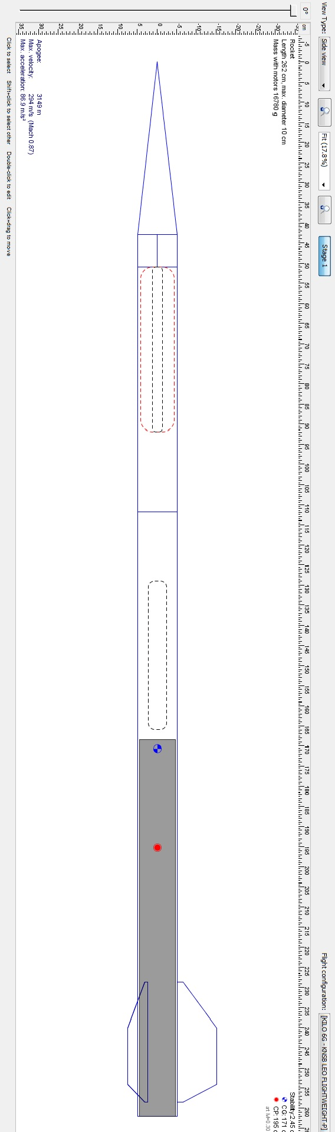
Fig.1 XOZ-XL dimensions

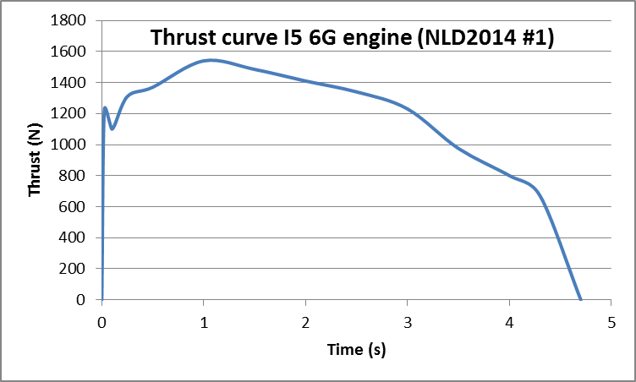

The 6G-90mm-LEO motor is identical to the Intimidator 6G engine with respect to:
- Grain size (core, inhibitor etc is the same)
- Number of grains and setup
- The converging and diverging angle of the nozzle
- Chamber size is identical

However the motor is designed to be less heavy:
1 Casing is 86*3 (90*5 for the I5)
2 Nozzle is made of solid graphite and electrolytically coated with copper to improve the mechanical properties of the outside of the nozzle.
3 Forward closure and nozzle are secured by seeger rings

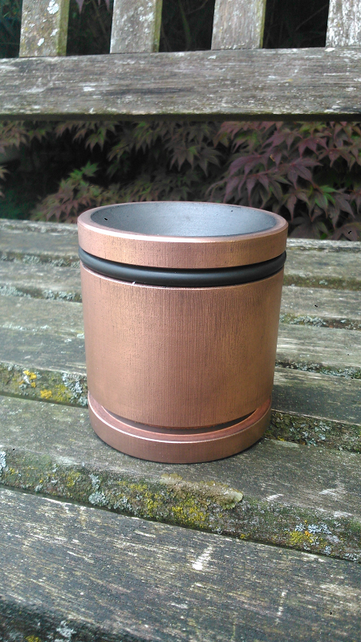
Fig.2 Solid copper coated graphite nozzle

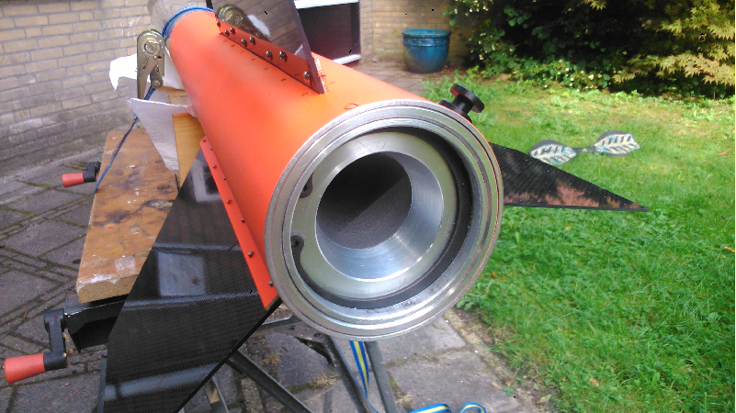

Fig.3 Graphite nozzle, aluminium retainer ring and seeger ring.

